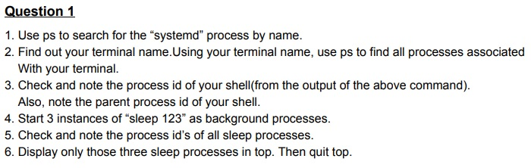

Step 1 :

Used below command to search for systemd by name

Ps –e | less

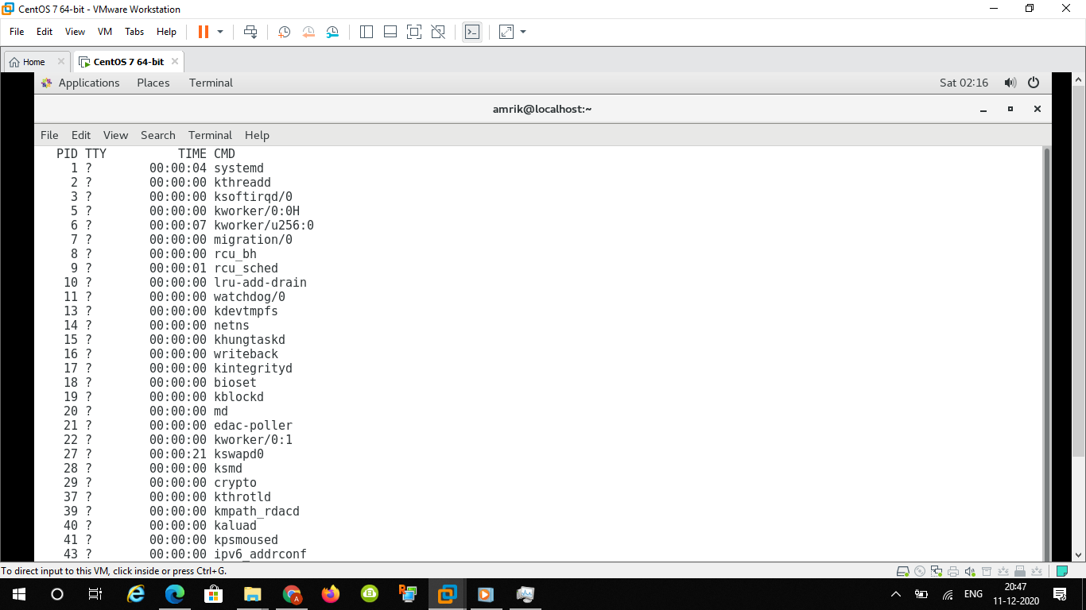

pc – e | grep – i “systemd”

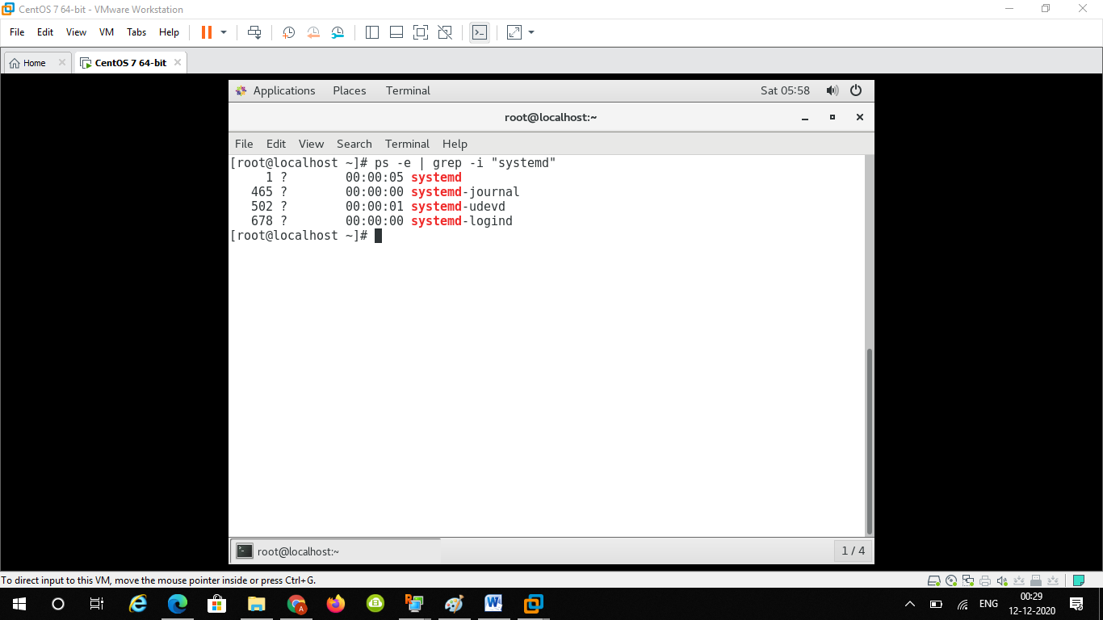

Step 2 :

To check my terminal name I used w command to see my terminal name and as well as ps –e

My user is pts/0

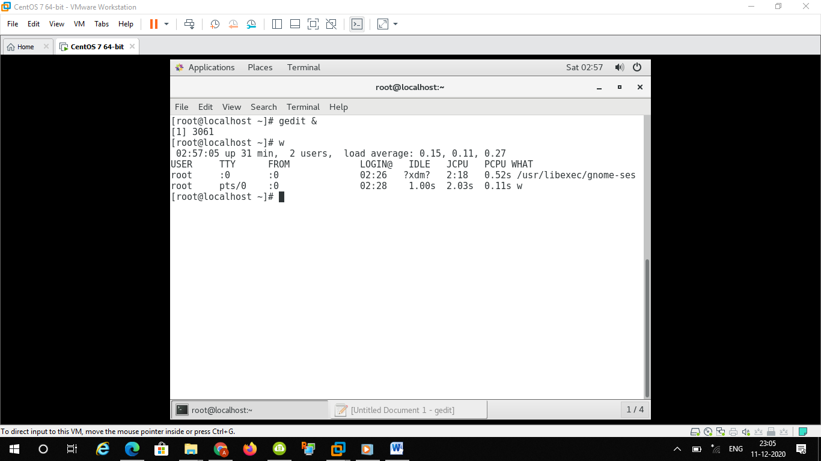

Few processes associated with my terminal

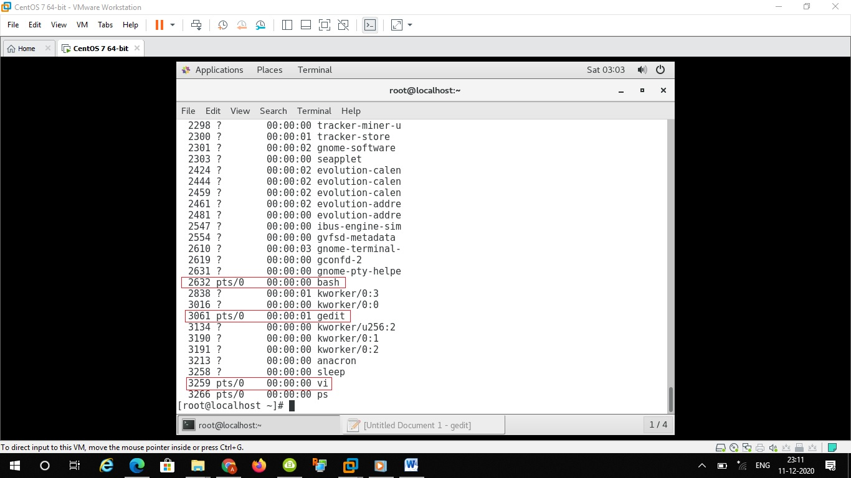

Step 3 :

My terminal name is pts/0 and I started from bash with PID 2632 then opened vi editor,gedit & Mozilla firefox which is having 2632 as PPID as below

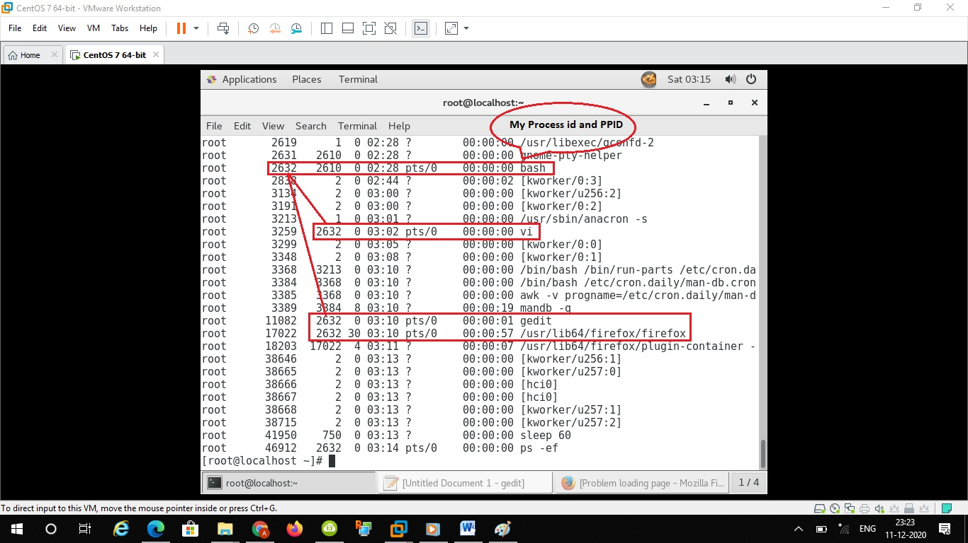

Step 4 : started sleep 123 as background process as below as it’s also showing process id as well

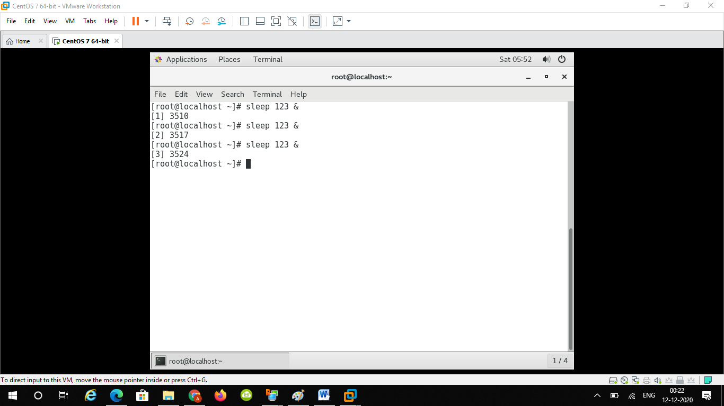

Step 5 : checked process id’s of started sleep 123 process using ps -e

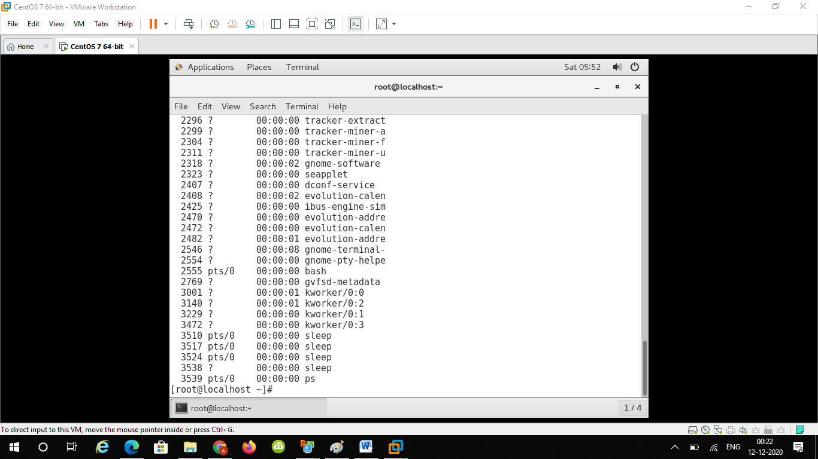

Step 6 :

To display sleep 123 process in top used below command

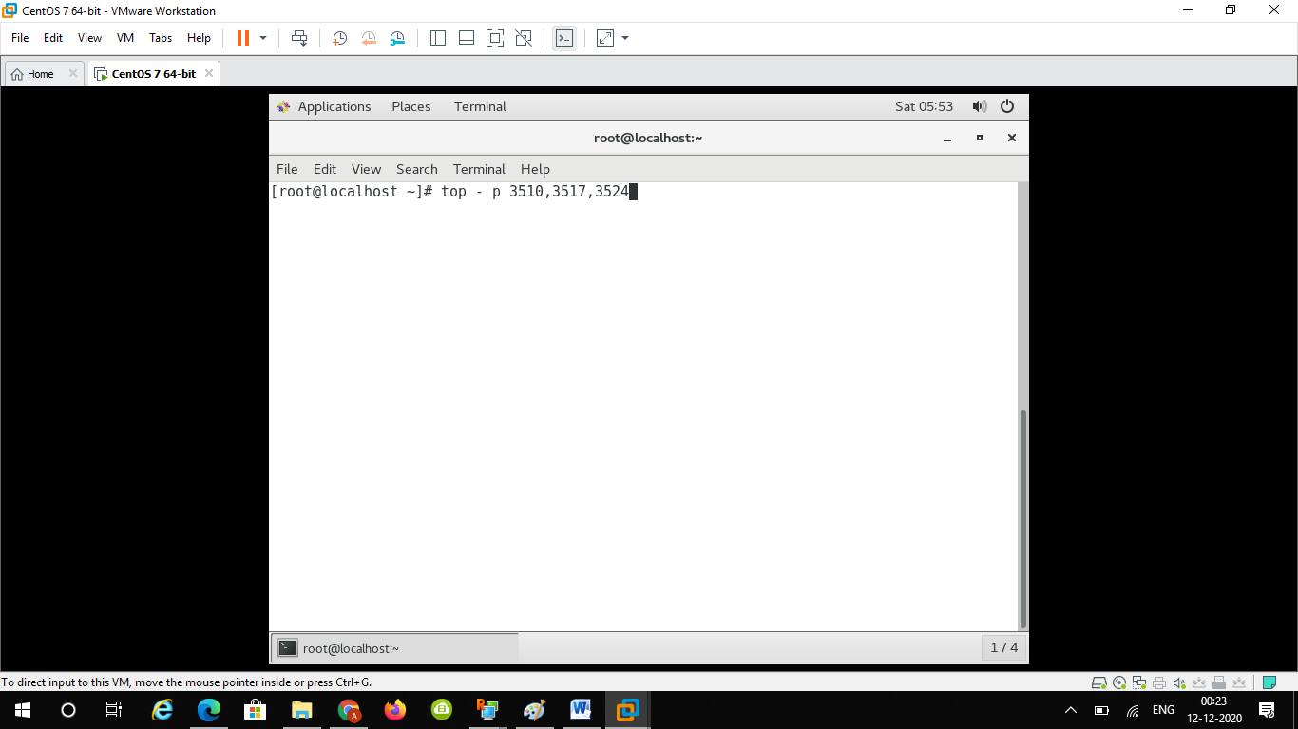

And after that q to quit

